What is six sigma? (1,11,10,8,7,9,ppt-3 of Vishwa notes)
- Six Sigma (6σ) is a set of techniques and tools for process improvement. It was introduced by American engineer Bill Smith while working at Motorola in 1986.
- A six-sigma process is one in which 99.99966% of all opportunities to produce some features of a part are statistically expected to be free of defects.
- Six Sigma strategies seek to improve manufacturing quality by identifying and removing the causes of defects and minimizing variability in manufacturing and business processes.
- The term Six Sigma originates from statistical modeling of manufacturing processes.
- Six sigma aims to reduce the time defects and variability
- You can produce a defect free product 99.99966% of the time allowing only 3.4 errors per 1 million opportunities
Six Sigma Key Words
- Improving Customer relationships
- Improved profitability
- Service/Industrial /Environment growth
- Technology advantages
- Global geographic coverage
- Innovation
- Development of our people
- Greening of environment and Business
- Data is getting bigger and bigger
What is Quality
- QUALITY is the degree to which an abject or entity that satisfies a specified set of attributes or requirements
- Quality is how good something is
- Fitness for use
- Fitness for purpose
- Delighting customers
- Conformation to specification’s
- Freedom from defects
- A distinctive attribute or characteristics proposed by someone
- A characteristic that satisfies the customer need

- 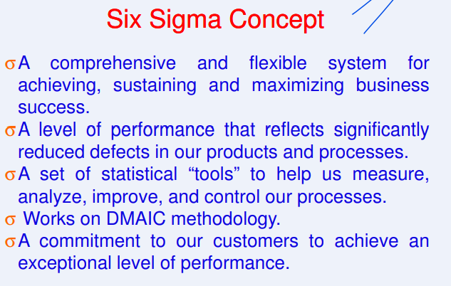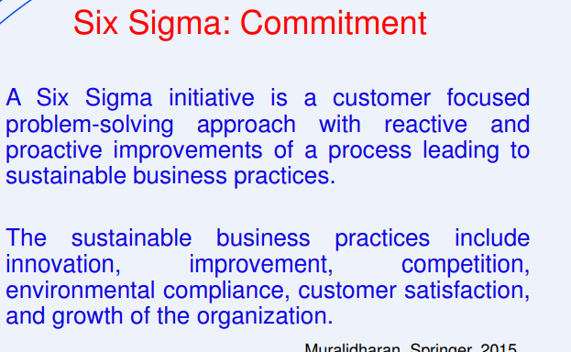
Quality Concepts
Deming’s Quality concept (1900-1993)
- He was an American engineer, statistician, professor author, lecturer and management consultant
- Deming taught that by adopting appropriate principle of management organizations can increase quality and simultaneously reduce costs

Fourteen principles for management (imp)
- Create a constant purpose towards improvement
(Plan for quality in the long term)
(Resist reacting with short term solutions)
- Adopt the new philosophy
(Create your quality vision and implement it)
- Stop depending on inspections
(Build quality into the process from start to finish)
(don’t just find what you did wrong eliminates the wrongs)
- Use a single supplier for any one item
(Analyze the total cost to you, not just the initial cost of the product)
(Use quality statistics to ensure that suppliers meet your quality standards)
- Improve constantly and forever
(Continues improve your systems and process deeming promoted the “Plan-Do-Check-Act” approach to proses analysis and improvement)
(use “Kaizen” and a model to reduce waste and improve productivity)
- Use training on the job
(Built a foundation of common knowledge)
- Implement leadership
(Figure out what each person actually needs to do his or her best)
- Eliminate Fear
(Make worker feel valued and encourage them to look for better ways to do things)
- break down barriers between departments
(Focus on collaboration and consensus instead of compromise)
- Get rid of unclear slogans
(Let people know exactly what they want don’t make them guess)
- Eliminate management by objective
- Remove barriers to pride of workmanship
- Implement education and self-improvement
- Make transformation everyone job
Deming seven deadly disease
- Lack of constancy of purpose
- Emphasis on short*-term profits
- Evaluation of performance, merit rating, or annual reviews
- Mobility of top management
- Running a company on visible figures alone
- Excessive medical costs
- Excessive costs of liability, swelled by lawyers that woke on contingency fees
PDSA = Plan, Do, Study, Act
Dr joseph meses juran (1904-2008).
- Considered to be the architect of quality
- One of the key persons in Japan’s quality transformation after World War II
- Jurans trilogy (PCI = quality planning, quality control, quality improvement)
- Juranas 3 role model (supplier, process, and customer)
- Trilogy is imp that is meant to reduce the cost of poor quality by planning quality into the process.
Philips Crosby (1926-2001)
- Quality deployment champion
- Promoted the concept of zero defect and cost of quality
(DIRFT) Doing it right the first time
(Zero defect is a way of thinking and doing that reinforces the motion that defects are not acceptable DIRFT “the idea here is that with a philosophy of zero defects, you can increase profits both by eliminating that cost of failure and increasing revenues through.)
Dr Genichi Taguchi
- He was an engineer and statistician
- Taguchi develop a methodology for applying statistics to improve the quality of manufactured goods
- Quality engineering and robust design
- Quality can be built into design with less effort and high impact in the design phase
- To increase profit, we must reduce costs
- To reduce cost, we must optimize product and process design
Other Quality Concept
- Kaizen concept (Continuous Improvement)
- Lean Concept (identifying root causes and waste reduction)
- Total Quality Management (TQM)
- 5S Concept (improve productivity)
- Poka Yoke
- Statistical Process/Quality Control (SPC/SPC)
- Six Sigma
Six Sigma Concept (imp)
- A comprehensive and flexible system for achieving, sustaining and maximizing business success.
- A level of performance that reflects significantly reduced defects in our products and processes.
- A set of statistical “tools” to help us measure, analyze, improve, and control our processes.
- Works on DMAIC methodology
- A commitment to our customers to achieve an exceptional level of performance.
- Six sigma identifies he process that are off target and have a high degree of variation and corrects the process
Six Sigma: Commitment (imp)
- A Six Sigma initiative is a customer focused problem-solving approach with reactive and proactive improvements of a process leading to sustainable business practices.
- The sustainable business practices include innovation, improvement, competition, environmental compliance, customer satisfaction, and growth of the organization.
Benefits of six sigma
- Customer satisfaction
- Cycle time reduction
- Customer retention
- Waste reduction
- Cost reduction
- Productivity improvement
- Market-share consolidation
- Defect reduction
- Product development
- Service development
Value of six sigma
Defect reduction = improve yields = improve customer satisfaction = higher share price
- Good quality is good business
- Variation is enemy of quality
- Six sigma creates a new mindset
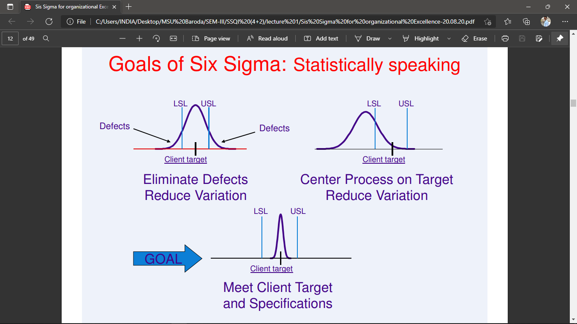
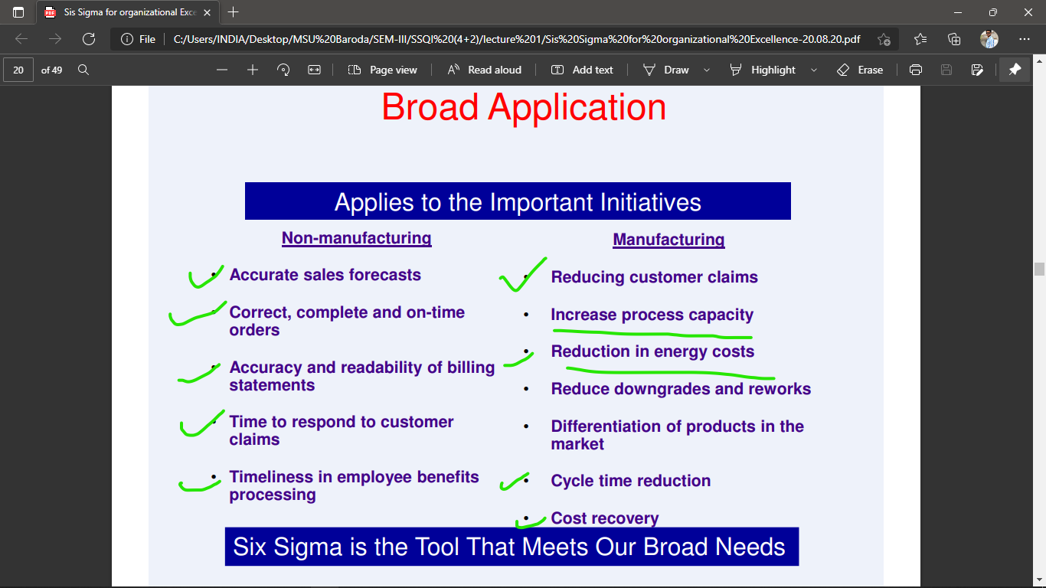
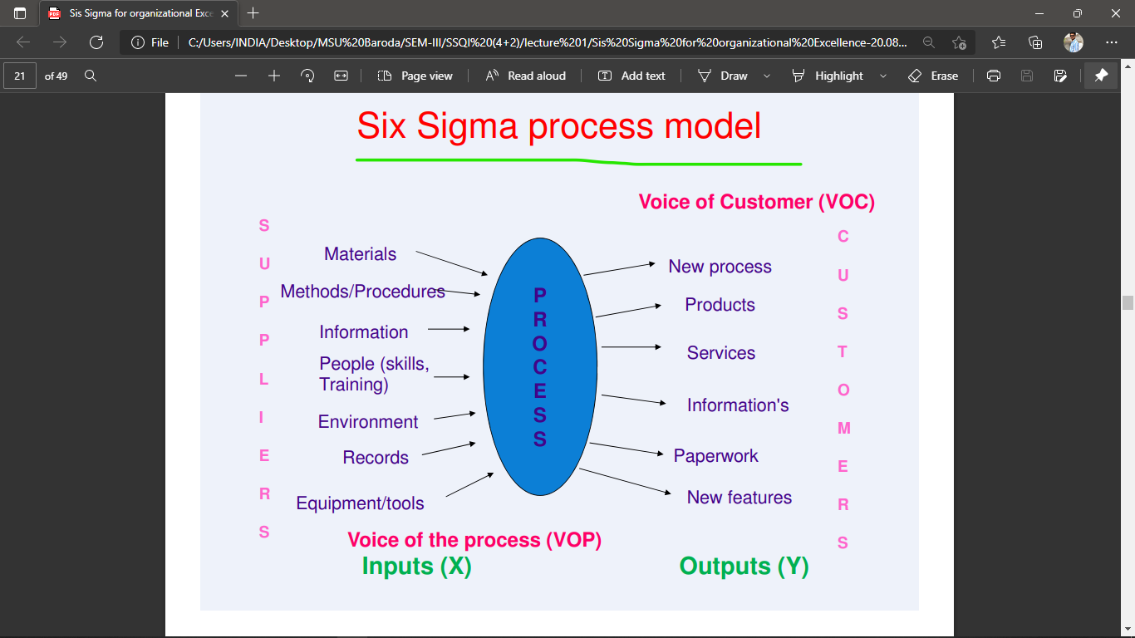
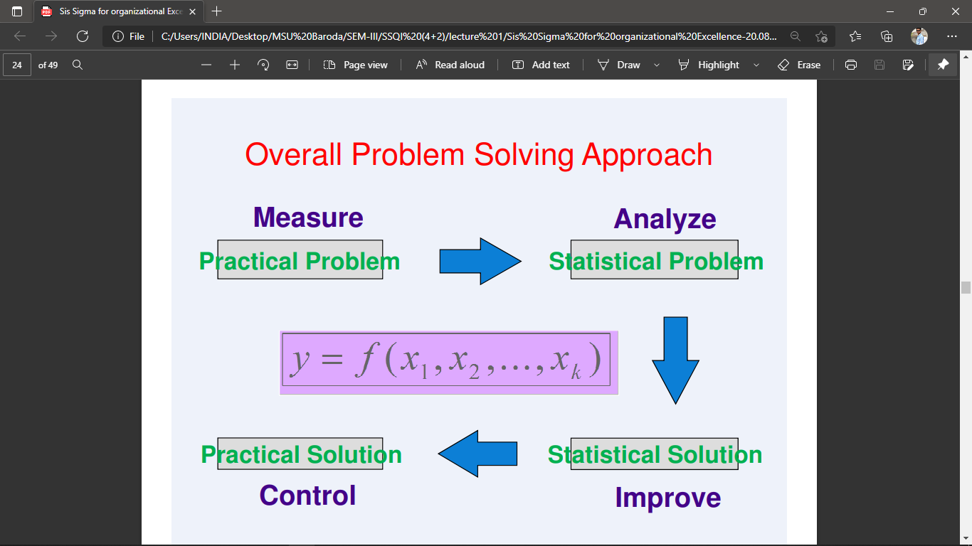
Eight dimensions of quality
- Performance: will the product do the intended job?
- Reliability: how often does the failure?
- Durability: how long does product last?
- Serviceability: how easy is to repair the product?
- Aesthetics: what does the product look like?
- Features: what does the product do?
- Perceived quality: what is the reputation of the company or its product?
- Conformance to quality: is the product made exactly as the designer intended?
Measuring of quality
- Quality is specification driven – does it meet the set performance requirement
- Quality is measured at start of life – percent passing specification acceptance
- Quality effectiveness is observable by number of rejects from customers
(The quality characteristics of a product or service are known as the ‘Determinants of Quality’. These are the attributes customers look for to decide if it is a quality product or service)
What is a defect?
- Classically, a defect is anything that fails to meet the consumer’s expectations or requirements.
- Defect is anything that blocks your process
Sigma concept of measuring defects
- Higher sigma level the fewer the number of defects per unit of product
- Lower the sigma level the grater the number of defects per unit of product
- With only 3.4 defects per million opportunities for creating a defects
How is high level of quality justified?
This cycle of detection, analysis and correction is directly connected to the three elements of customer satisfaction:
- Delivering the highest quality products and services (defect free products and services)
- On-time delivery with least cycle time
- Right price (all elements of manufacturing costs)
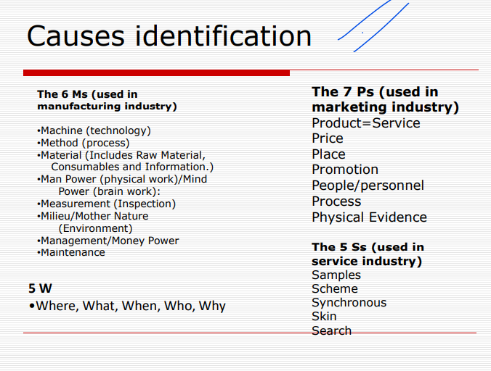
What is a “Cause and Effect Diagram”? (imp)
A cause-effect diagram is a visual tool used to logically organize possible causes for a specific problem or effect by graphically displaying them in increasing detail, suggesting causal relationships among theories. A popular type is also referred to as a fishbone or Ishikawa diagram. Cause-Effect can also be diagrammed using a tree diagram.

When diagnosing the cause of a problem, a cause-effect diagram helps to organize various theories about root causes and presents them graphically.

The C-E Diagram is a fundamental tool utilized in the early stages of an improvement team. The ideas generated during a brainstorming or affinity process are used to populate the diagram. Since the list of issues on a C-E may be very large, the team should use a prioritization or multi-vote technique to narrow the list of potential cause that they desire to investigate farther.

At the head of the diagram is the “Effect” that the team is investigating. The team brainstormed potential causes for this effect. The skeleton becomes the various potential causes and the headers are the column heads from the affinity diagram.

NOTE:
- Good Quality is Good Business
- Variation is the enemy of quality
- Defects cause problems to customers and producer’s and hence Six Sigma’s goal is to prevent and reduce defects
- Systematic and dedicated approach is required to prevent and reduce defects
- Statistical methods become the core of DMAIC techniques
- Six sigma creates a new mindset
Examples of processes
- Order generation
- Order fulfillment
- Open enrollment process
- identifying customer requirements
- Engineering change process
- Collection of money
- Invoicing customers
- Scheduling logistics
- Equipment maintenance process
- Acquisition

Business goals and objectives
- Business goals and objectives are part of planning process
- They describe what a company expect to accomplish within a given period
- These goals and objectives might pertain to the company as a whole department employs customers and even marketing efforts
- Companies use specific amusements to keep track of their good and objective
A goal describes where you want to be in the future however unlike an objective, it does not explain how you plan to get there
- Gaols are: general, broad, abstract, strategic
- Objectives are: specific, measurable, narrow, tactical
Dashboards
- A data dashboard is an information management tool that visually tracks, analyzes and displays key performance indicators (KPI) and key data points to monitor the health of a business, department or specific process
- Behind the sense a dashboard connects to your file attachments services and KPI s but on the surface displays all this data in the form of table line charts bar charts
- A data dashboard provides a central location for business to monitor performance
- A dashboard is visual displays of all of your data
Dashboards Examples
- Management KPI Dashboard.
- Sales Cycle Length Dashboard.
- Procurement Data Analytics Dashboard.
- Web Analytics Dashboard.
- Human Resources Data Dashboard.
- Manufacturing Production Dashboard.
- IT Data Analytics Dashboard.
- Logistics Transportation Dashboard.
Digital Dashboards: Benefits
- Visual presentation of performance measures
- Ability to identify and correct negative trends
- Measure efficiencies/inefficiencies
- Ability to generate detailed reports showing new trends
- Ability to make more informed decisions based on collected business intelligence
- Align strategies and organizational goals
- Saves time compared to running multiple reports
- Gain total visibility of all systems instantly
- Quick identification of data outliers and correlations
KPI (Key performance indicators)
- KPI refers to a set of quantifiable measurements used to gauge a company overall long-term performance
- KPI specially help determine a company strategic financial and operational achievements especially compared to those of other business within the same sector
Key performance indicators
Revenue growth, revenue per client, profit margin client retention rate, customer satisfaction
Types of dashboards
(Operational, strategic, analytical)
Balance Business Score Card (BSC) or Customer Goals
- A balanced scorecard is a strategy performance management tool – a semi-standard structured report, that can be used by managers to keep track of the execution of activities by the staff within their control and to monitor the consequences arising from these actions.
Types of BSC.
Financial perspectives
- Revenue, Expense, ROI (return on investment), NET Income, profit margin, improve cash flow, proper revenue mix, lower bad loans and lower debt
Customers
- Increase customers satisfaction, increase customers loyalty, customers retention, high quality service
Learning and growth
- Employee skills, employee training, employee retention, satisfaction, employee growth and turnover, proper knowledge management
Internal business processes
- Cross sell products, fast business decisions and approvals, inventory, quality control, product lead time
Why is BSC so important?
- The Balanced Scorecard can be used to guide the design of performance reports and dashboards.
- This ensures that the management reporting focuses on the most important strategic issues and helps companies monitor the execution of their plan.
- Focus on most imp strategic issues and helps companies to monitor the execution of their plan
BSC: Benefits
- Better Strategic Planning
- Improved Strategy Communication & Execution
- Better Alignment of Projects and Initiatives
- Better Management Information
- Improved Performance Reporting
- Better Organizational Alignment
- Better Process Alignment
Voice of Customer
- Voice of the customer (VOC) is a term used in business and Information Technology to describe the in-depth process of capturing a customer's expectations, preferences and aversions.
- VOC is a term describes your customers feedback about their experience with and expectations for your products or services.
- It focuses on customer needs expectations, understandings
- VOC: survey, analysis, actions, realization, dialogue, information
- It is a market research technique that provides a detailed set of customers wants and need
- VOC studies typically consist of both qualitative and quantitative research steps
- They are generally conducted at the start of new product
- Customer’s comment, customer issues, requirement
Steps involved in building an effective VOC analytics program
- Identify a question.
- Gather and prepare data.
- Choose your tools.
- Analyze and troubleshoot.
- Draw conclusions
- Take action
VOC: Benefits
- Understand your customers’ requirements.
- Make informed business decisions that align with customer needs and expectations
- Discover market fit and nail the timing of new product launches
- Improve brand management and brand reputation.
- Increase customer retention.
- Minimize negative feedback and experiences.
How to measurer VOC?
- Net Promoter Score. The Net Promoter Score (NPS) measures whether a customer would personally recommend your product or service to a family member, friend, or colleague. ...
- Customer Effort Score. ...
- Overall Customer Satisfaction. ...
Loyalty Index
Voice of the Process (VOP)
- The Voice of the Process is the way the process communicates performance in relation to customer expectations and needs. These communications take place via process metrics, which are indicators of the current state of the process. To establish a baseline, it is important to know how the current state operates before you attempt any changes or improvements. It is crucial not to alter a process without understanding the current performance or variation.
- The Voice of the Process (VOP) basically describes what the process is telling you:
what the process is able to achieve
- whether the process is under control or not
- the individual measurements are a signal that something is wrong or is just a part of a normal variation
- among others.
One of the best ways to find out the Voice of the Process is to use a control chart.
- Voice of Process is the performance of a process over a period of time.
- The upper and lower limits can be plotted on the Process Performance graph showing the gap between the Voice of Customer and the Voice of Process.
- If the VOP is lying within the VOC, then everything is fine with the process.
Quality Function Deployment (imp)
- Quality function deployment (QFD) is a “method to transform user demands into design quality, to deploy the functions forming quality, and to deploy methods for achieving the design quality into subsystems and component parts, and ultimately to specific elements of the manufacturing process.”,
- Dr Yoji Akao, who developed QFD in Japan in 1966
- The three principles of QFD are analysis and integration, diversification and visualization, and generalization and localization.
- 4 phases of QFD? = product planning, product development, process planning and production planning.
QFD: Characteristics
- QFD is designed to help planners focus on characteristics of a new or existing product or service from the viewpoints of market segments, company, or technology-development needs. The technique yields charts and matrices.
- QFD helps to transform customer needs into the engineering characteristics for a product
QFD: Techniques
- House of Quality
- We need to first figure out Customer need/ wants (VOC) = it is time to identify the importance so you have to brainstorm (what do you think) the customer wants in terms of importance = now time to develop engineering requirement (HOWS) = now we want to fill values in relationship matrix =n now we need to define relative importance = next we will be doing competitors analysis
- House of Quality (Figure 1), the QFD methodology focuses on the most important product or service attributes or qualities. These are composed of customer wows, wants, and musts.
- Pugh concept selection (decision matrix)
- Allows you to choose between a list of alternatives based on the criteria
- Was developed by Stuart Pugh
- Pugh Concept Selection can be used in coordination with QFD to select a promising product or service configuration from among listed alternatives
- Modular Function Deployment
- Modular Function Deployment uses QFD to establish customer requirements and to identify important design requirements with a special emphasis on modularity.
- Modularity = is subdivided the system into small parts it’s called module and then used in different system
- Hoshin Kanri process
- The QFD-associated Hoshin-Kanri process somewhat resembles Management by objectives (MBO), but adds a significant element in the goal setting process, called "catchball".
- How to solve the emerging
- Aligning different level of the organization
- Ensuring the flow of ideas both top and down and bottom up
Note:
DMAIC (imp)
- Define - Define the problem or project goals that need to be addressed
- Measure - Measure the problem and process from which it was produced
- Analyze - Analyze data and process to identify the root causes of defects and opportunities
- Improve - Improve the process by finding solutions to fix, diminish, and prevent future problems
- Control - Implement, control, and sustain the improvements and solutions to keep the process on the new course
DMADV (imp)
- Define – Define the problem and/or new requirements
- Measure – Measure the process and gather the data that is associated with the problem or in comparison to the new requirements
- Analyze – Analyze the data to identify a cause-and-effect relationship between key variables
- Design – Design a new process so that the problem is eliminated or new requirements are met
- Validate – Validate the new process to be capable of meeting the new process requirements
DMEDI (imp)
- Define – Define the problem and/or new requirements
- Measure – Measure the process and gather the data that is associated with the problem or in comparison to the new requirements
- Explore – Explore the data to identify a cause-and-effect relationship between key variables
- Develop – Develop a new process so that the problem is eliminated or new requirements are met
- Implement – Execute the new process under a control plan
Note:
- POPULATION A population consists of all the items or individuals about which you want to draw a conclusion.
- SAMPLE A sample is the portion of a population selected for analysis.
- PARAMETER A parameter is a numerical measure that describes a characteristic of a population.
- STATISTIC A statistic is a numerical measure that describes a characteristic of a sample.
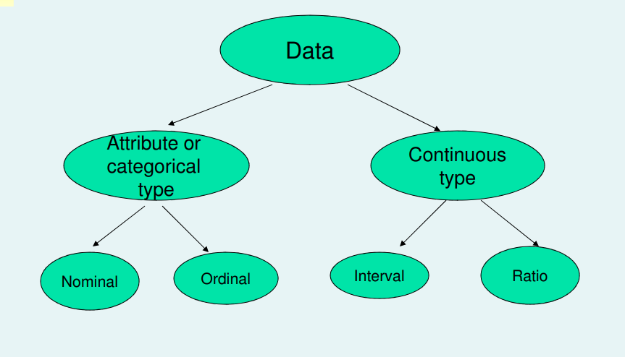
- A nominal scale classifies data into distinct categories in which no ranking is implied.
- An ordinal scale classifies data into distinct categories in which ranking is implied
- Interval scale
- More powerful measurement than ordinal scale
- Mean is the most appropriate measure of central tendency
- Correlation, t-test, F-test are generally used for this type of scaling
4. Ratio scale
- Interval data that has an absolute zero
- Measurement on any continuous scale

BRAIN STORMING
What is brain storming (imp)
- Brainstorming is a simple but effective technique for generating many ideas of a group of people within a short span of time to solve a given problem.
- Brainstorming is a group activity where each participant shares their ideas as soon as they come to mind.
- Brainstorming allows people to think more freely, without fear of judgment.
Basic Rules for Brainstorming
1) Defer evaluation (Deferring Judgment):
- To defer judgment, don't stop to evaluate any ideas during the brainstorm and never ever say that an idea is stupid or won't work.
- This rule will keep the momentum going and keep the group coming up with new ideas.
- Nothing kills the energy in a brainstorm faster than criticism. Not to mention that the person who offered the idea will feel embarrassed and will be less likely to continue contributing.
2) Fantasize Freely (Freewheeling Method):
- The participants are encouraged, urged to let themselves go and generate ideas, no matter how fanciful these ideas are.
- "Freewheeling" is welcomed
3) Build On Ideas (Combine and Improve Ideas):
- Idea of one participant is more effectively built up by another participant.
- Combine concepts to create new solutions.
- Evaluate each idea to determine which are feasible, innovative, and best suited to accomplish your goal.
4) Generate Quantity
- Generate as many ideas as possible.
- Here we want quantity; the more creative ideas the better.
- As a facilitator, you can even make it a challenge to come up with as many ideas as possible and compare this team’s performance to the last brainstorming session you conducted.
Principles Of Brainstorming
- Deferment of evaluation develops the appropriate psychologically safe climate for ideation
- The uniqueness of each participants’ knowledge is tapped to develop new insights
- Ideas of one participant tend to trigger off ideas in the 5
- Ideas of one participant tend to trigger off ideas in the brains of other group members
- Free association encourages fruitful ideation
- The pressure of time bound sessions in a non-threatening atmosphere is conducive to a high productivity of ideas
- brainstorming instructions are essential and should emphasize, paradoxically, number and not quality of ideas
- a specific, difficult target should be set for the number of ideas
- individuals, not groups, should generate the initial ideas
Steps To Brainstorming
- Choose the topic
- Each member, in rotation, is asked for ideas
- Each member offers only one idea per turn, regardless of how many he/she has in mind
- This continues until all the ideas have been exhausted
- Ideas are to be recorded and displayed on transparent sheets
Ways To Effective Brainstorming
- Give everyone a chance to speak
- Do not criticize ideas
- Record all ideas
- Ideas are expanded and used to come up with
- Ideas are expanded and used to come up with more ideas
- Free expression in any language that the person giving the idea is most comfortable with
When To Use the Brainstorming
- To find a solution to a specific problem
- To suggest counter measures when the target has not been achieved
- To select a theme/topic
- To find causes of a specific problem
- Use it when new ideas are required, to generate a large list of possibilities.
- Use it when a solution to a problem cannot be logically deduced.
- Use it when information about a problem is confused and spread across several people, to gather the information in one place.
Key Points-Brainstorming
- Acquaint the participants with the technique of Brainstorming. A warm-up session of this nature developed later helps.
- Obtain the commitment of the management to encourage the development and implementation of worthwhile ideas.
- Set up appropriate criteria to evaluate the several ideas considered worthwhile.
- Screen all the ideas generated.
- Keep participants advised of the final choice of the ideas and the actions initiated.
Benefits Of Brainstorming
- Individual is limited in generating ideas and that group produces more ideas
- Ideas are improved upon by members
- Presence of others increases creativity
- Pooling of ideas and resources is made possible by coming together as a group

Continuous Improvement Methodologies
Overview of Lean
Evolution of Lean
Late 1940s: Lean originates in the Toyota production System
Focus: Toyoda & Ohno built on Ford’s continuous flow and Introduced speed & flexibility
Early 1990s: ‘The Machine that Changed the World’ by Womack, Jones, and Roo’s
Focus: Lean manufacturing system
Mid 1990s: Lean Manufacturing adopted TPS concepts
Focus: Improve profitability
2000+: Dozens of other companies (service, transactional & manufacturing) follow suit
Focus: A way of doing business
What is Lean? (Leaders Encouraging Activity and Nutrition.)
Eliminate waste through continuous improvement:
- Define value from the client’s perspective
- Identify the value stream
- Only make what the client pulls
- Keep the flow moving continuously
- Always improve the process
[ Lean is defined as a set of management practices to improve efficiency and effectiveness by eliminating waste. The core principle of lean is to reduce and eliminate non-value adding activities and waste.]
Goal:
Increase value-added time within the value stream (approx. 2-5%)
[The goal of lean is to eliminate waste—the non-value-added components in any process.]
What are the 5 principles of lean?
- value, value stream, flow, pull, and perfection
What is Value?
- Right capability provided to a client at the right time and the right price…as defined by the Client
- Clear understanding of who the Client is, is critical
- In Knowledge Flow, value is addition, modification or screening of useful knowledge or information that facilitates a commercial transaction.
- Activities that add no value to the client are by definition “waste”
- the definition of value in lean is everything the customer is willing to pay for.
What is a Value Stream?
- Time Series of all activities & steps (Both Value Add and Non-value Add) required to bring a Product, Service or Capability to the Client
- Value Streams cut across Functional Boundaries
- Value Streams are usually mapped out by product or product family
- Most Value Streams have 2-5% Value Added Time
What is Flow?
- A perfect process has continuous flow as products, services and knowledge are transformed continuously without delay from step to step
- Flow is created by eliminating queues and stops and improving process flexibility & reliability
- Lean flow refers to how people or items involved in the manufacturing process are moved from step to step, from the start of the process to the end.
- Clearly, the target of Lean flow is to ensure that a product or item moves as quickly as possible through the process without affecting customer satisfaction or product quality.
[ Waste points us to problems within the system • Unevenness creates overburden that undercuts your efforts to eliminate waste]
Lean Cost Model [Price – cost (-) = profit (+)]
Lean Method Model
Traditional Model:
- Increases the workforce
- Increases working hours
Lean Model
- Eliminates waste
- Focuses on efficient use of equipment and people
- Minimizes issues by standardizing work
- [ Lean focuses on simplifying complexity and providing the right product in the right amount at the right time]
- [ Higher value to client will result into higher sales]
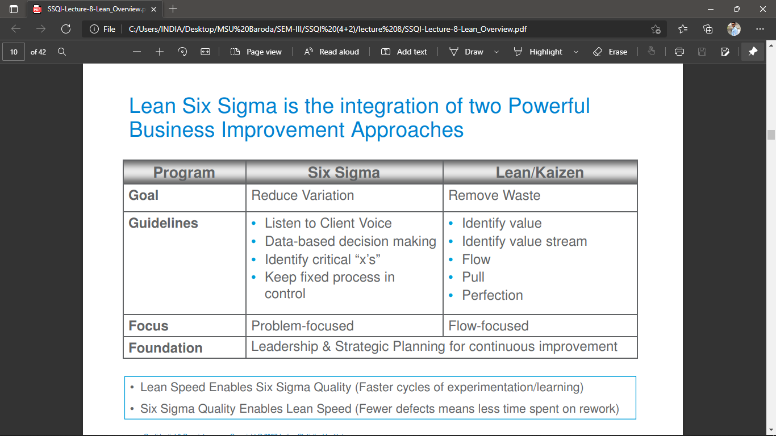
- [ Higher sales will result into higher shareholder value]

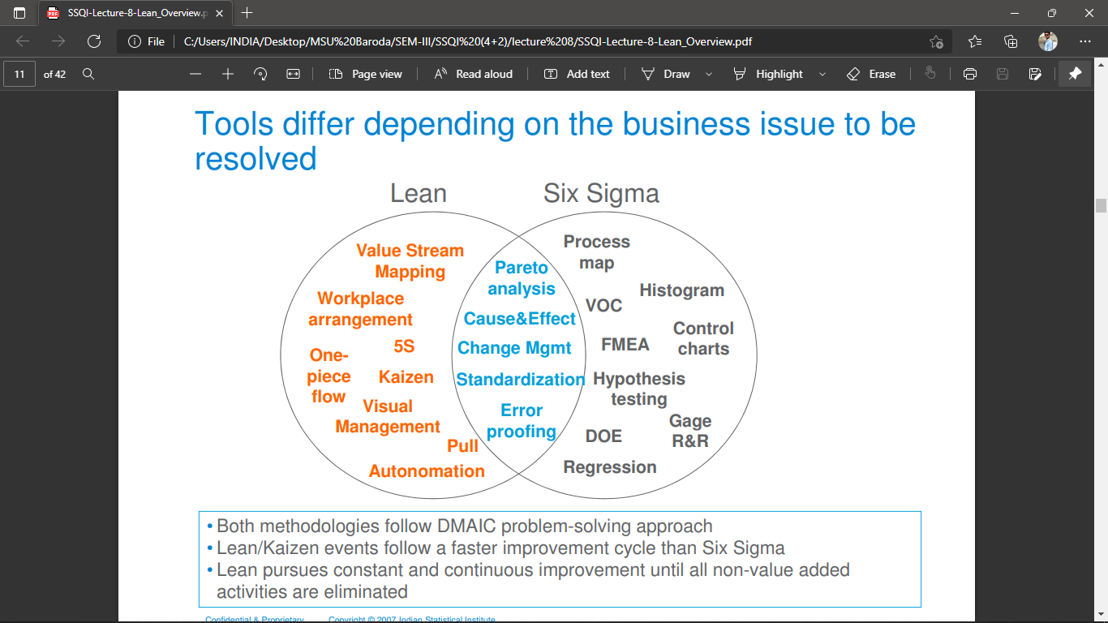
Lean
- Speed and flexibility • Involve all employees, Positive results in short time-frame, Focused on smaller scale projects. Less scientific: Often trial and error
Six Sigma
- In-depth root cause analysis and solutions, builds highly trained and skilled staff, used for solving more complex, larger issues, used for solving more complex, larger issues. Robust infrastructure
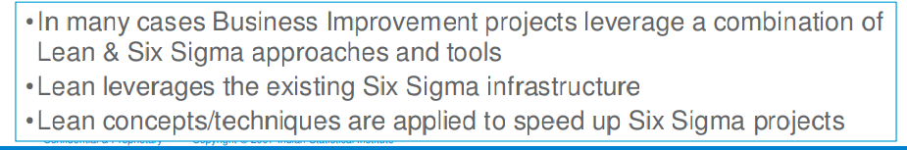

8 types of waste - Ohno (Toyota Production System)
1. Transport. The transport waste is defined as any material movement that doesn’t directly support immediate production. An improper facility layout, poor production planning, poor scheduling can generate transport waste. Another example is poor workplace organization, which results, in unnecessary additional material transport.
2. Inventory. The inventory waste refers to any supply in excess of process requirements necessary to produce goods or services in a Just-in-Time manner. Causes of inventory waste include inaccurate forecasting systems, inefficient processes or suppliers, long changeover times, unbalanced production processes, or poor inventory planning and tracking.
3. Motion. The motion waste is defined as any movement of people that doesn’t contribute added value to the product. Examples include moving equipment, reaching or bending, or gathering tools more than necessary, as well as unnecessarily complicated procedures. The Motion waste is often caused by ineffective plant layouts, lack of visual controls, poor process documentation, or poor workplace organization.
4. Waiting. The waiting waste refers to as any idle time that occurs when codependent events aren’t fully synchronized. Examples of this waste include idle operators waiting for equipment, production bottlenecks, production waiting for operators, and unplanned equipment downtime. Waiting can be caused by inconsistent work methods, lack of proper equipment or materials, long setup times, low man/machine effectiveness, poor equipment maintenance, or skills monopolies.
5. Overproduction. Overproduction is defined as producing more than is needed, faster than needed, or before it’s needed. Automation in the wrong places, lack of communication, local optimization, low uptimes, poor planning, and a just in case reward system can cause overproduction waste.
6. Over-processing. Over-processing refers to any redundant effort in production or communication that does not add value to a product or service. Over-processing waste includes endless product or process refinement, excessive information, process bottlenecks, redundant reviews and approvals, and unclear customer specifications. It is caused by decision-making at inappropriate levels, inefficient policies and procedures, lack of customer input concerning requirements, poor configuration control, and spurious quality standards.
7. Defects. The defect waste is defined as the loss of value do to the scrap, repair, or rework of a product that deviates from specifications. Excessive variation in production processes, high inventory levels, inadequate tools or equipment, incompatible processes, insufficient training, or transport damage due to poor layouts and unnecessary handling can all lead to defect waste.
8. Unutilized talent. The waste of unutilized talent refers to underutilizing or engaging employees in a process. This could take the form of employees performing unnecessary work when their talent could be utilized in activities that add greater value, or not utilizing employees’ critical thinking abilities and feedback in processes. Unutilized talent also includes allowing employees to work in silos, which prevents them from sharing their knowledge.
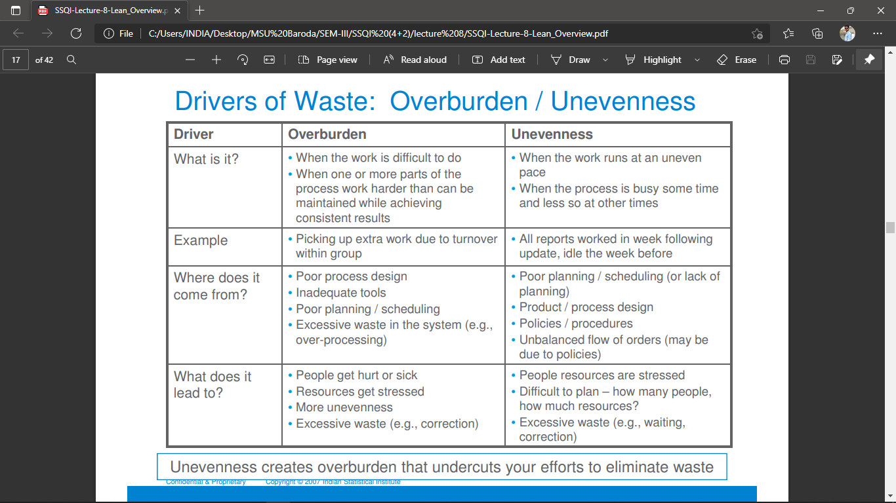

3M - Lean Six Sigma
three enemies of Lean: Muda (waste), Muri (overburden) and Mura (unevenness)
Muda. Muda means wastefulness, uselessness and futility, which is contradicting value-addition. Value-added work is a process that adds value to the product or service that the customer is willing to pay for. There are two types of Muda, Type 1 and Type 2. Muda Type 1 includes non-value-added activities in the processes that are necessary for the end customer. For example, inspection and safety testing does not directly add value to the final product; however, they are necessary activities to ensure a safe product for customers. Muda Type 2 includes non-value-added activities in the processes, but these activities are unnecessary for the customer. As a result, Muda Type 2 should be eliminated.
Mura. Mura means unevenness, non-uniformity, and irregularity. Mura is the reason for the existence of any of the seven wastes. In other words, Mura drives and leads to Muda. For example, in a manufacturing line, products need to pass through several workstations during the assembly process. When the capacity of one station is greater than the other stations, you will see an accumulation of waste in the form of overproduction, waiting, etc. The goal of a Lean production system is to level out the workload so that there is no unevenness or waste accumulation.
Muri. Muri means overburden, beyond one’s power, excessiveness, impossible or unreasonableness. Muri can result from Mura and in some cases be caused by excessive removal of Muda (waste) from the process. Muri also exists when machines or operators are utilized for more than 100% capability to complete a task or in an unsustainable way. Muri over a period of time can result in employee absenteeism, illness, and breakdowns of machines. Standardize work can help avoid Muri by designing the work processes to evenly distribute the workload and not overburden any particular employee or equipment.
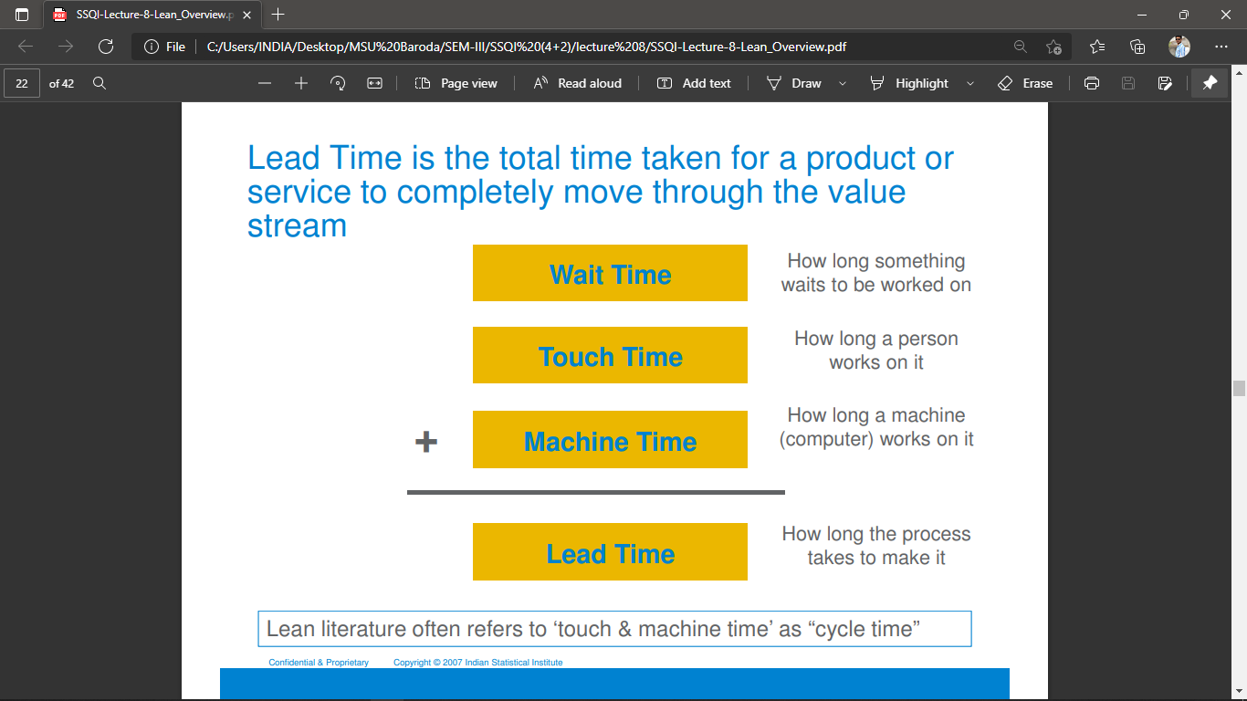
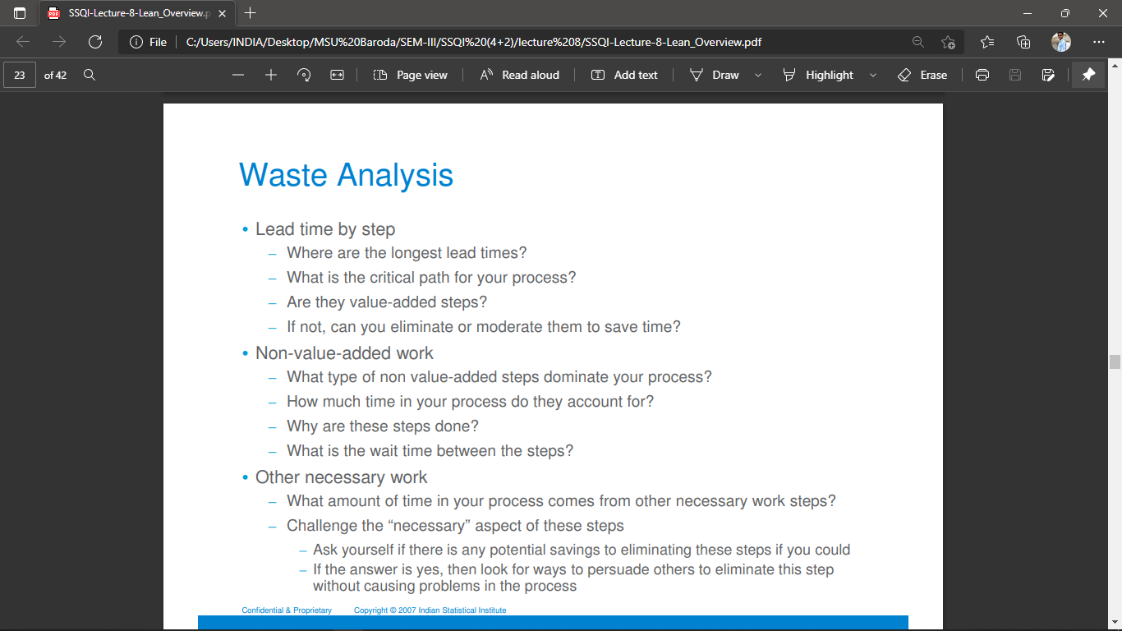
What is value added and non-value-added activities? (imp)
Value-Added Activities: These are those activities for which the customer is willing to pay for.
Non-Value-Added Activities: These are those activities for which the customer is not willing to pay for. Non-value-added activities are also called "wastes,"
Value Added activities: These activities are those which adds value to a business process or product and for which customer is willing to pay. Value Added activities help in converting a product from a state of raw material to a finished product in the least possible time, at minimum costs. It aims at completing a business activity correctly the very first time, and helping the business to deliver the product or service while fully conforming to customer requirements or specifications.
Non-Value-Added activities: These are those which do not add any value to the product or service but are an inherent part of the process. Customers are not willing to pay for such services. These activities prove to be a burden on the organization and affect its efficiency. Valuable resources in the organization are engaged in completing these activities despite the fact that such activity is slowing the progress of the organization.

5S –Concept (imp)

5S can either stand alone as a set of concise Kaizen activities or it can be used selectively to prepare an area for additional improvements.
5S is a systematic method to organize, order, clean, and standardize a workplace - and to keep it that way.
The 5S pillars, Sort (Seiri), Set in Order (Seiton), Shine (Seiso), Standardize (Seiketsu), and Sustain (Shitsuke) provide a methodology for organizing, cleaning, developing, and sustaining a productive work environment
Sort
Eliminate whatever is not needed by separating needed tools, parts, and instructions from unneeded materials.
In this first step, workers sort everything in a workspace into what is and what is not needed. Some use a system called “red tagging” in which every item not necessary for a process gets red-tagged during the sort phase. These items are set aside and evaluated later. Workers store seldom used items nearby, but not at the workstation. They discard unsafe items and clutter.
[ Remove all items from the workplace that are not needed for current production or clerical operations]
Set in order
Organize whatever remains by neatly arranging and identifying parts and tools for ease of use.
Set, or Set in Order, follows the advice: “A place for everything and everything in its place.” Workers position items based on use, with frequently needed items kept closer at hand. Every item that made it through the Sort stage is given storage space. In some cases, workers can use color-coded labels to easily identify storage spaces.
[ ♣ Arrange needed items so that they are easy to use ♣ Label items so that they are easy to find and put away ♣ Determine how many of each item will be stored in each location ♣ Make it easy for anyone to find, use and return items]
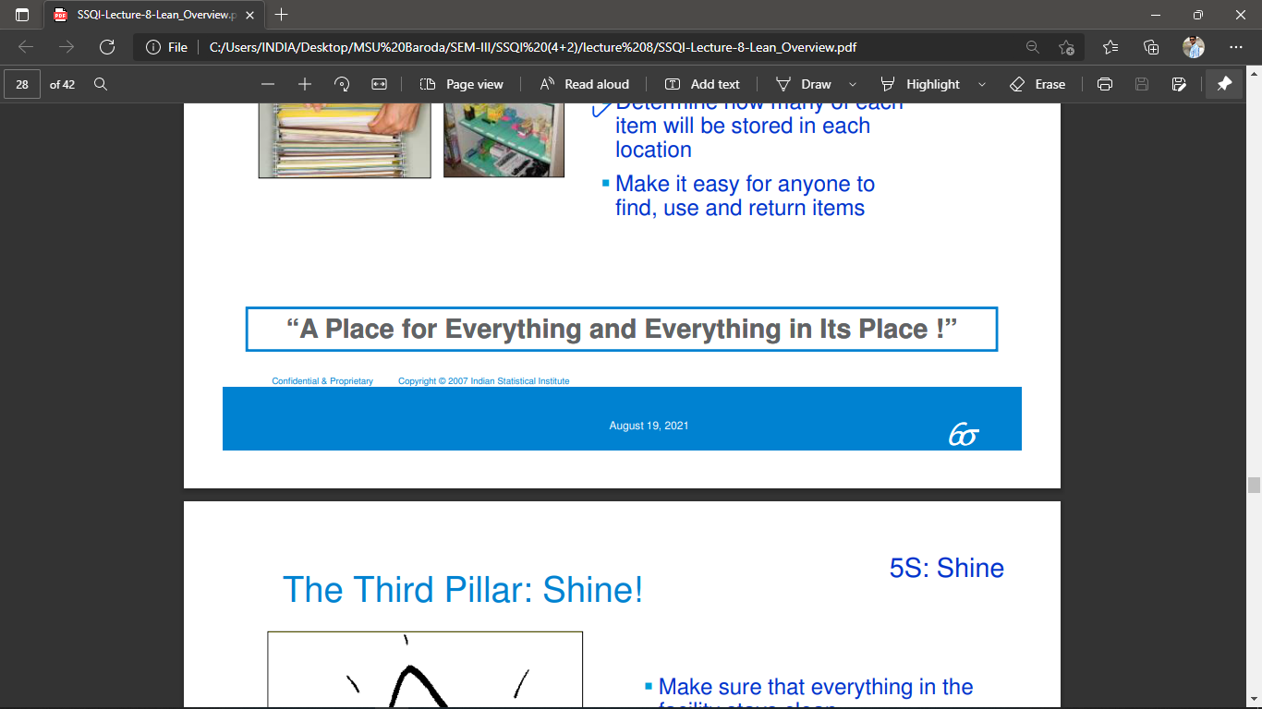
Shine
Clean the work area by conducting a cleanup campaign.
With the clutter gone and storage space organized, it’s time to clean. After a thorough initial cleaning, workers clean the station every day (sometimes twice a day). This maintains the gains made in the Sort and Set phases. Cleaning includes storage areas, machines, equipment, tools and work surfaces.
[ Make sure that everything in the facility stays clean ♣ Clean to inspect, inspect to detect, detect to correct and correct to prevent]
Standardize
Schedule regular cleaning and maintenance by conducting seiri, seiton, and seiso daily.
The Standardize phase takes the progress and changes in behavior from the first three steps and makes them the standard procedure
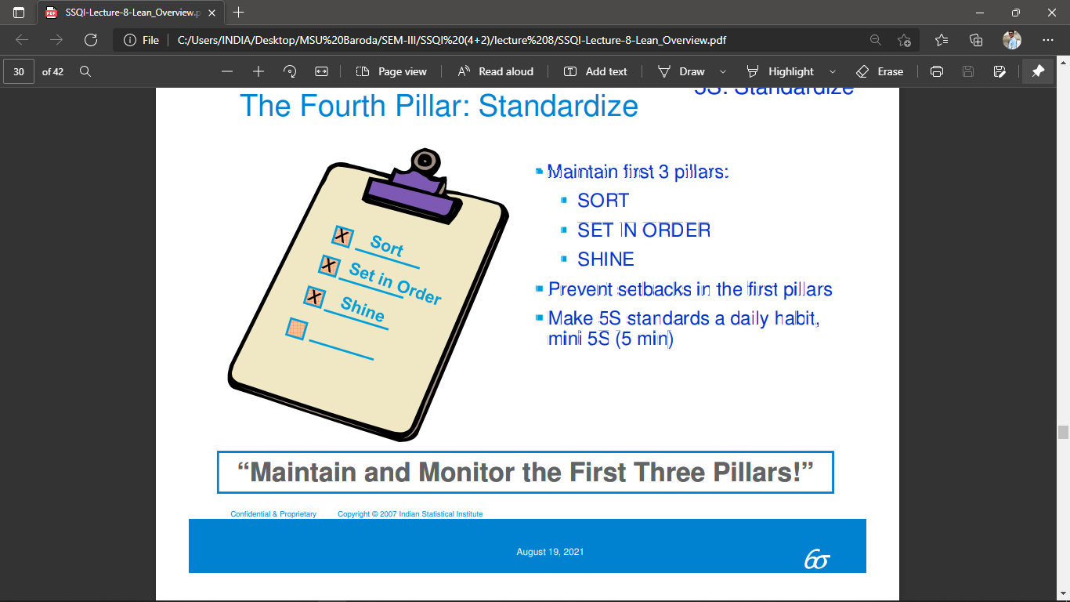
Sustain
Make 5S a way of life by forming the habit of always following the first four S’s.
Developing the habit of always observing the first four S’s makes 5S a way of life.
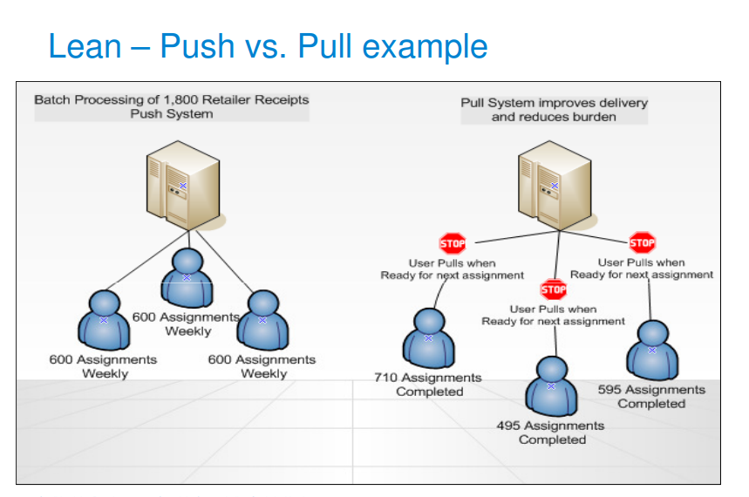

One Piece Flow
The concept of One-Piece Flow is to move one piece of work, one at a time, between different steps in the process.
Prevents the build-up of work-in-process (WIP) between processes
Allows for faster detection and correction of errors
Aides in balancing workload and defining resource requirements.
Level Loading
- A technique used to balance production throughput according to the needs of customers. Provides comparable workflow across an organization or department.
Lean – Autonomation
- Autonomation describes a feature of machine design to effsect the principle of "Jidoka" used in the Toyota Production System. Autonomation, or Jidoka, may also be described as "intelligent automation'" or "automation with a human touch."
Visual management shares information, promotes prevention and supports continuous improvement
- Information sharing: – Real time view/status of the process: Daily/hourly update of workin-process – Key performance indicators show progress against targets – Signal system that alerts associates of a problem
- Prevention: Visible standards to prevent variation & abnormalities – Work instructions/checklists to simplify process
- Continuous improvement: – Easy to identify downward trends, opportunities for improvement – Communication of project team results to recognize and encourage continuous improvement

SIX SIGMA provides two techniques to identify the “critical few” measures
- Prioritization matrix
- FMEA
Why Develop a Prioritization matrix?
- identifies the critical few variables that need to be measured and analyzed
- helps to focus the data collection effort
- helps formulate theories about causes and effects
Why to use a Prioritization matrix
- too many variables that might have an impact on the output of the process
- collecting data about aa possible variables would cost to much time and money
- team members have different theories about what happens in the process
How to construct a Prioritization matrix for input/Process variables
- list all output variables
- rank order and weight the output variables
- list all input and process variables
- evaluate the strength of the relationship between output and input process variable
- cross-multiply weight and correlation factor
- Highlight the critical few variables
FAILURE MODE AND EFFECT ANALYSIS (FMEA) (imp)
- Any FMEA conducted properly and appropriately will provide the practitioner with useful information that can reduce the risk (work) load in the system, design, process, and service.
Benefits of FMEA
- Captures the collective knowledge of a team
- Improves the quality, reliability, and safety of the process
- Logical, structured process for identifying process areas of concern
- Reduces process development time, cost
- Documents and tracks risk reduction activities
- Helps to identify critical-to-quality characteristics
- Provides historical records; establishes baseline
- Helps increase customer satisfaction and safety
- Increased customer satisfaction, Prioritization of product/process deficiencies,
- documentation and tracking of the actions taken to reduce risk
- Identifies known and potential failure modes
- Identifies the causes and effects of each failure mode
- Prioritizes the identified failure modes according to the risk priority number (RPN)-the product of frequency of occurrence, severity, and detection
- Provides for problem follow-up and corrective action
When Is the FMEA Started?
- When new systems, designs, products, processes, or services are designed
- When existing systems, designs, products, processes, or services are about to change regardless of reason
- When new applications are found for the existing conditions of the systems, designs, products, processes, or service
- When improvements are considered for the existing systems, designs, products, processes, or services
When is the FMEA Complete?
Is there a time when the FMEA may be considered finished or complete? Yes. Only when the system, design, product, process, or service is considered complete and/or discontinued.
Who conducts the FMEA?
The FMEA is a team function and cannot be done on an individual basis.
FMEA
There are two primary flavors of FMEA:
- Design FMEAs are used during process or product design and development. The primary objective is to uncover problems that will result in potential failures within the new product or process.
- Process FMEAs are used to uncover problems related to an existing process. These tend to concentrate on factors related to manpower, systems, methods, measurements and the environment. Although the objectives of design and process FMEAs may appear different, both follow the same basic steps and the approaches are often combined.
FMEA drives systematic thinking about a product or process by asking and attempting to answer three basic questions:
• What could go wrong (failure) with a process or system? • How bad can it get (risks), if something goes wrong (fails)?
• What can be done (corrective actions) to prevent things from going wrong (failures)?
FMEA attempts to identify and prioritize potential process or system failures. The failures are rated on three criteria:
• The impact of a failure - severity of the effects.
• The frequency of the causes of the failure - occurrence.
• How easy is it to detect the causes of a failure - detectability.
Conducting an FMEA: Basic Steps
1. Define the scope of the FMEA.
2. Develop a detailed understanding of the current process.
3. Brainstorm potential failure modes.
4. List potential effects of failures and causes of failures.
5. Assign severity, occurrence and detection ratings.
6. Calculate the risk priority number (RPN) for each cause.
7. Rank or prioritize causes. Use the information for data collection effort.
8. In analysis/implementation phases take action on high-risk failure modes.
9. Recalculate RPN numbers.

Poka-Yoke
“Defects arise because errors are made; the two have a cause-and-effect relationship…. Yet errors will not turn into defects if feedback and action take place at the error stage”
Poka-Yoke systems create a process in which a worker cannot create an error. Parts and/or process are designed so that desired results are inevitable.
Poka-Yoke Systems (TYPES OF ERRORS)
1. Forgetfulness: Forgetting a step or a part Safeguard: Checklist, Visual Standard Operating Procedure
2. Errors due to Misunderstanding: Not very familiar with the required operation Safeguards: Continuous Training, Visual SOP
3. Errors in Identification: Problems in identification or clearness of required steps or parts. Safeguards: Training, Visual Training, Standardization
4. Errors due to Lack of Experience: New Employees Safeguard: Skill Building & Training, Work Standardization
5. Errors due to Lack of Standards: No clear way to perform the task or job Safeguards: Standard Operations, Visual Instructions
6. Errors due to Machine Readability: Machine out of spec Safeguards: TPM, Critical Parts List, Maintain Equipment History List.
Mistakes Happen for many reasons, but almost all can be prevented if we take the time to identify WHEN & WHY they happen and take steps to prevent the recurrence of these errors and mistakes by using a systematic approach to Mistake Proofing aimed at eliminating foreseeable errors.
Poka-Yoke Systems (ELEMENTS OF PROCESS)
- Information
- Material
- People
- Methodology / Procedure
The four elements of process determine whether an output is correctly manufactured or not. Defect Free Processes are a result of Controlled Standards of Operation in each of these principal areas.
Two ways to Inspect
1. After the process is completed (separate good work from bad work)
2. Prior to starting the process (conditions are right for the process to perform quality work)
Inspection should
- improve the process
- prevent defects by increasing the speed with which quality feedback is received
Inspection should NOT
- sort out defect
Candidates for Poka-yoke in a process
❖Inputs ❖ Outputs ❖ Feedback ❖ Results
Poka-Yoke Should be Considered When:
✓ Worker Vigilance is Required ✓ Mispositioning is Likely ✓ SPC is Difficult ✓ External Failure Costs Far Exceed Internal Failure Costs
POKA-YOKE 8 MAIN PRINCIPLES
- Build Quality into the process
- All inadvertent errors and defects can be eliminated
- Stop Doing it wrong and start doing it right - now!!!
- Do not think up excuses, think about doing it right
- An 80 % chance of success is good enough - Focus on implementation
- Attack defects and errors as a team
- Ten Heads are better than one - Brainstorm ideas, Discuss, Think
- Seek out the root cause, use the 5 Whys
Human Errors are usually inadvertent. Poka-Yoke devices help us to avoid defects before they occur, even when human errors are made.
Poka-Yoke is a tool that builds Quality into the process and shifts the attention from detection and inspection to building it right the first time.

Kaizen
What is a Kaizen Event?
A Kaizen event is a focused effort used to “make a leap” A multi-functional team is formed and for a 3–5-day period they focus on resolving a problem.
It is characterized by the following:
- A short burst of intense activity & effort (3 to 5 days only)
- Biased toward action over analysis
- Focused on improving the value stream and achieving flow
- Driven to resolving a specific problem or achieving a specific goal
- Focused on a specific area or process (either plant or office)
- Managed with daily reviews of progress
- Aimed at achieving specific improvements in a short time
- Managed to resolution
A kaizen is driven to two imperatives: -
- Solving Problems
- Eliminating waste (Muda)
Kaizen is a term that has become synonymous with Continuous Improvement (CI)
Kaizen begins with the customer whose Needs Standards are always changing Which requires continuous improvement
Roles that support a Kaizen effort Upper Management must
✓ allocate resources ✓ establish strategy ✓ establish systems ✓ organize structure
Managers/ Supervisors must
✓ Monitor performance ✓ Ensure associates are educated and trained to use the tools ✓ Coach associates ✓ Improve Communications
Associates must
✓ Make suggestions ✓ Participate ✓ Learn new jobs and tools
Types of Kaizen
(Flow Kaizen) value stream improvement
(Process Kaizen) elimination of waste
Kaizen events are typically used to begin implementation of:
- Standard Work
- Flow
- 5S
- Visual Workplace
- Other Waste Reduction/Flow Improvement Efforts
Kaizen Event Steps
Document Reality
Document the Current Process. We need to understand how processes are performed today
- Calculate TAKT Time
- Kaizen Event Area Profile
- Target Sheet
- Time Observation
- Standard Worksheet
- Standard Work Combination Sheet
- Spaghetti Chart
- TAKT / Actual Bar Chart
- Layout
- 5S & Safety Audit
Identify Waste
Waste - Those elements of a process that do not increase the value of a product, but only increase cost.
Plan Countermeasures
- Focus on the things that can be done within the event
- Bias for action vs. planning and analysis
- Right sized resource
- Low-cost solutions, creativity before money
- Maximum Waste Elimination
Reality Check
- The E1 reviews the countermeasures and the to-do list and ensures:
- Proper Direction
- Countermeasures are the proper lean solutions
- If necessary, course corrections are made
- The E2 approves the plan.
Make Changes
- Bias for action, Just Do It!!
- Pre-event planning for possible event “moves” may be needed to prepare support services.
- Do not dictate how things will be done. Ask team members, build coalition
- Hold progress meeting each day; morning, afternoon, or end of day.
Verify Change
- Redo observations
- Results Achieved?
- If not, go back and make additional changes
- Re-verify with additional observations
- Take action that is needed to complete verification within the event time frame
Measure Results
- Document the results against the event objectives using the target sheet
- Did the waste get eliminated?
- Will the improvements contribute to the annual Timken lean6sigma Goals?
Make this the Standard
- Establish visual controls to ensure progress is maintained.
- Make controls visible and understandable to the casual observer.
- Visibly post open actions and leave them up until they have been completed.
- The facilitator is responsible to help establish control, counsel on the event closure.
- Establish a visual display board in each area.
- The results must be repeatable and sustainable.
But Remember that Kaizen Events
are the Beginning of the journey
NOT
the End of the journey

Quality tools (imp)
What is the event 7 basic quality tools?
- Cause-and-effect diagram (also known as the "fishbone diagram" or Ishikawa diagram)
- Check sheet. /Timeline chart/Gannt Chart
- Control chart.
- Histogram.
- Pareto chart.
- Scatter diagram.
- Stratification (alternatively, flow chart or run chart)

Cause-and-effect diagram (also known as the "fishbone diagram" or Ishikawa diagram)
- A Cause-and-Effect Diagram is a tool that helps identify, sort, and display possible causes of a specific problem or quality characteristic
Check sheet. /Timeline chart/Gannt Chart
- What is the function of check sheet?
- The check sheet is a form (document) used to collect data in real time at the location where the data is generated.
- Helps to analyze the data for corrective and preventive actions. Helps in making the Bar graph, Histogram and Pareto Chart.
Control chart
- A quality control chart is a graphic that depicts whether sampled products or processes are meeting their intended specifications. If not, the chart will show the degree by which they vary from specifications
Histogram.
- A Histogram is a Quality Control Tool that graphically displays a data set.
- More specifically, a Histogram is a type of Bar Chart that graphs the frequency of occurrence of continuous data, and will aid you in analyzing your data.
- A histogram is used to summarize discrete or continuous data. In other words, it provides a visual interpretation. of numerical data by showing the number of data points that fall within a specified range of values (called “bins”).
- Summarizes data from a process and graphically present the frequency distribution in bar form.
Pareto chart.
- In quality control, Pareto charts are useful to find the defects to prioritize in order to observe the greatest overall improvement.
- which helps to determine the most frequent defects, complaints, or any other factor. It is a visual tool widely used by professionals to analyze data sets related to a specific problem or an issue.
- Summarizes data from a process and graphically present the frequency distribution in bar form.
- A Pareto chart helps you decide where your improvement efforts will have the biggest payoff. Ultimately, you are trying to uncover clues that will help you pinpoint causes.
- Decide where to focus efforts.
Scatter diagram.
- Scatter diagram helps to confirm the degree of relationship between cause and effect. Here cause is an independent variable and effect is dependent variable.
- A Scatter Diagram is used in “Control Quality” process as a corrective action approach to understand causes of poor performance of dependent variable due to independent variable effect.
Stratification (alternatively, flow chart or run chart)
- Stratification (also known as Flow Chart and/or Run Chart) Stratification is a way to organize data, and in particular of separating data into meaningful groups. Stratification is also known as a flow chart or run chart.
- is used to determine the relationship between two or more sets of data. Stratification diagrams are helpful for making patterns visible when data is coming from a wide variety of sources.
- To study observed data for trends or patterns over a specified period of time.
- To track useful information for predicting trends.

Causes: Origin
- People: Anyone involved with the process
- Methods: How the process is performed and the specific requirements for doing it, such as policies, procedures, rules, regulations and laws
- Machines: Any equipment, computers, tools, etc. required to accomplish the job
- Materials: Raw materials, parts, pens, paper, etc. used to produce the final product
- Measurements: Data generated from the process that are used to evaluate its quality
- Environment: The conditions, such as location, time, temperature, and culture in which the process operates

